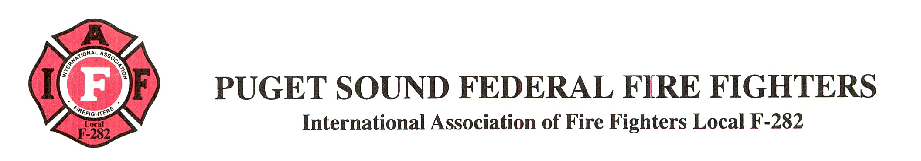

Date: today

To: Chief Canned Spray Cheese

From: FF I.M. Pissed

Re: Designation of Representative

1. The undersigned is designating FF Zealous Guardian as my representative for any issues related to the grievance regarding sick leave that was filed on January XX, 20XX. Mr. Guardian has full authority to act on my behalf for the purposes of this matter.

2. This designation of representative is in effect until revoked.

3. Mr. Guardian’s contact information is as follows:
XXXXX
XXXXXXXX
XXXXXXXXXX

I. M. Pissed

